- Acknowledgement:

I would like to express my sincere gratitude to all those who supported and guided me throughout the successful completion of my project titled "IoT-Based Food Spoilage Detection System."

First and foremost, I am extremely thankful to my project guide and faculty mentor, [Insert Faculty Name], for their valuable guidance, encouragement, and insightful suggestions at every stage of the project. Their continuous support and feedback helped me enhance the quality and direction of my work.

I would also like to extend my heartfelt thanks to the Head of the Department, faculty members, and lab assistants of the Department of Computer Applications, for providing the required resources, lab facilities, and a collaborative environment to carry out this project efficiently.

I am grateful to my friends and classmates for their motivation, constructive discussions, and assistance during the implementation and testing phases of the project.

Lastly, I would like to thank my family for their constant support, encouragement, and patience throughout the development process. Their unwavering belief in my abilities kept me motivated.

This project has not only deepened my technical understanding of IoT and embedded systems but also enhanced my problem-solving and practical implementation skills. I am truly thankful for this learning experience.

- INTRODUCTION:

The food we consumes provides nourishment and gives energy to our body, it gives us the ability to do daily activities and help improves our health in direct as well as indirect ways. A healthy and fresh diet is the most important way to keep ourselves fit. The food items kept at room temperature undergo rapid bacterial growth and chemical changes in food. Taking unhealthy food leads to bad health, and can cause different food borne diseases. Indian scenario is even worse with foodborne illnesses causing outbreaks in almost every part of the country. Though most foodborne diseases are sporadic and often not reported in India, a nationwide study carried out recently reported an alarming prevalence of 13.2% at the household level. The scientific reports on the outbreak of foodborne diseases in India for the past 29 (1980–2009) years indicated that a total of 37 outbreaks involving 3485 persons have been affected due to food poisoning.

Today, in most of the hostel mess and government schools' kitchen everybody is getting affected by the food they consume. Fruits like banana and other food items used in daily life, as all of them do not offer quality since their moisture, harmful gases vary from time to time. To ensure food safety it should be monitored at every stage of the supply chain. When foods start decaying it produces some gases like ethanol, methane in it. These gases increase with time. The purpose of this system is to detect early food spoilage before signs are visible.

Food safety and hygiene is a major concern in order to prevent the food wastage. The Quality of the food needs to be monitored and it must be prevented from rotting and decaying. Therefore, it is useful to deploy quality monitoring devices at food stores. These quality monitoring devices keep a watch on the environmental factor that cause or pace up decay of the food.

About 351,000 people die of food poisoning globally every year. In some countries, majority of people struggle on daily basis for food, due to preservation of foods and use of chemicals to artificially increase the time span of food causes people illness. Food contamination is more dangerous because very often food does not look bad even though severely infected, it may appear quite normal. The presence of highly dangerous toxins and bacterial spores is often not detected until after an outbreak of food poisoning, laboratory examination uncovers the infecting agent. It is necessary to develop a system that can help people to identify the freshness of food or quality of food items.

- Overview:

The IoT-based Food Spoilage Detection System is an innovative solution designed to monitor and detect spoilage in stored food items using sensors and microcontrollers. This smart system integrates various components like gas sensors (IR or ultrasonic for freshness detection), temperature monitors, WiFi modules (ESP8266), and a microcontroller (Arduino Uno) to track environmental conditions such as temperature, humidity, and gas emissions that indicate spoilage. Real-time data is displayed on an LCD screen and can be transmitted over the internet for remote monitoring via IoT. Visual indicators like LEDs alert users about food status, making it an ideal solution for homes, grocery stores, and food transportation systems.

This project leverages the power of IoT and embedded systems to create a compact, low-cost solution for food safety. Using sensors like IR and ultrasonic, the system can detect changes in the environment that often lead to spoilage, such as the release of certain gases, rise in temperature, or humidity levels. The Arduino Uno acts as the brain of the system, processing sensor data and triggering alerts through LEDs or LCD messages. Integration of the ESP8266 WiFi module allows for seamless data transmission to cloud servers or mobile apps, enabling users to monitor food conditions remotely. The system can be installed in refrigerators, storage containers, or warehouses, providing a smart way to automate food quality checks and maintain freshness.

Benefits:
- Real-Time Monitoring:
  - Continuously tracks food conditions like gas emission and temperature.
  - Notifies users immediately when spoilage is detected.
- Remote Access:
  - Data can be accessed from anywhere via IoT using ESP8266 WiFi module.
  - Useful for industries and supply chain management.
- Reduces Food Wastage:
  - Early detection helps prevent spoilage.
  - Ensures better food preservation.
- Cost-Effective and Scalable:
  - Built using affordable components.
  - Can be scaled for larger storage units or commercial use.
- User-Friendly:
  - Simple LCD display and LED indicators for easy understanding.
  - Portable and can be customized easily.

- LITERATURE STUDY

  - B. Ravi Chander , P.A.Lovina, G.Shiva Kumari ( April 2020) studied Food Quality Monitoring System By Using Arduino. It is useful to deploy quality monitoring devices at food stores. These quality monitoring devices keep a watch on the environmental factor that cause or pace up decay of the food. Later, the environmental factors can be controlled like by refrigeration, vacuum storage etc. In this paper, a similar food quality monitoring device will be designed that will keep watch of environmental factors like temperature, humidity, alcohol content and exposure to light.

- The device is built on Arduino UNO which is a popular prototyping board. The Arduino board is interfaced with various sensors like DHT-11 to monitor temperature and humidity, MQ4 to detect alcohol content and LDR to measure exposure to light. This is an IoT device and sends the measured sensor data to an IoT platform. The ESP8266 Wi-Fi Modem is interfaced with the Arduino to connect it to the internet via Wi-Fi router. The sensor data is also displayed on a character LCD interfaced with the Arduino UNO. The IoT platform used for logging and monitoring of sensor data is embedded spot.

- Suruchi Parmar, Tejawini Manke, Neha badhan, Prasad Borase , Prof. N.S.Ujgare Studied on the topic “An efficient system to detect freshness and quality of food”. They noted the ethanol level in banana sample. Initially when banana started to ripe it produced a little mount of ethanol. This amount of ethanol increased with time. And using MQ3 sensor they detected that the fruit has starting decaying. They also have studied about “Real time Milk monitoring system” in which they calculated the pH level of milk and detected whether milk is spoiled or good to use.

- "EFresh – A Device to Detect Food Freshness” (September 2018) In this the authors Naveed Shahzad, Usman Khalid used biosensor and electrical sensors to check out the freshness of food. A smart system that may sight the freshness of food like farm things, meat, and fruits. The identification and choice of hydrogen ion concentration device, moisture sensor, and the Gas sensor was used to develop a wise food freshness detector that ensures the freshness of food and tells whether or not to eat it or bin it. An android application developed to select the type of food to be checked.

- • Ki Hwan Eom, Min Chul Kim proposed “The Vegetable Freshness Monitoring System Using RFID with Oxygen and Carbon Dioxide Sensor”(2012). An oxygen and carbonic acid gas concentration observation system for freshness management, which supports radio frequency identification (RFID). Freshness can be checked by varying factors as well as wetness, temperature, oxygen, and carbonic acid gas. Here, the authors focused on oxygen and carbon dioxide. The concentrations of these two gases are related to freshness and affect the food. This system used a device for observation of gases and connected the device with the associate RFID tag. The RFID system was found to be relatively easy to manage. With this combined system, it calculated the freshness of vegetables.
- Theory:

1) Arduino UNO R3:
Arduino is an open-source platform used for building electronics projects. Arduino consists of both a physical programmable circuit board (often referred to as a microcontroller) and a piece of software, or IDE (Integrated Development Environment) that runs on your computer, used to write and upload computer code to the physical board.
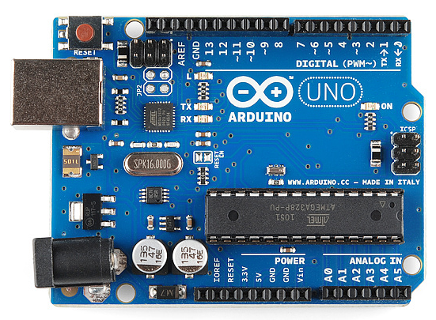
The Arduino platform has become quite popular with people just starting out with electronics, and for good reason. Unlike most previous programmable circuit boards, the Arduino does not need a separate piece of hardware (called a programmer) in order to load new code onto the board -- you can simply use a USB cable. Additionally, the Arduino IDE uses a simplified version of C++, making it easier to learn to program. Finally, Arduino provides a standard form factor that breaks out the functions of the micro-controller into a more accessible package.
2) MQ3 Sensor:
The MQ3 gas sensor is a widely used sensor for detecting alcohol, ethanol, and other gases in the air. It is highly sensitive and ideal for applications like breath analyzers, air quality monitoring, and food spoilage detection.
Key Features:
- Detects Alcohol & Organic Vapors: Especially sensitive to alcohol, it can also detect ethanol, benzene, smoke, and other organic vapors.
- Analog & Digital Output: Provides both analog voltage output and digital signal output for flexible integration with microcontrollers.
- Fast Response Time: Quickly reacts to changes in gas concentration in the surrounding environment.
- Operating Voltage: Works efficiently at 5V, making it suitable for Arduino-based projects.
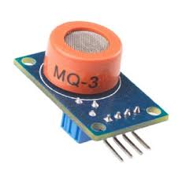
3) WIFI ESP8266 SENSOR
• The ESP8266 is a low-cost Wi-Fi microchip, with a a full TCP/IP stack and microcontroller capability.
• This small module allows microcontrollers to connect to a Wi-Fi network and make simple TCP/IP connections
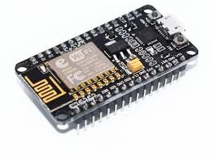
4) BREADBOARD:
- A Breadboard is a widely used tool to design and test circuit
- We do not need to solder wires and components to make a circuit while using a bread board.
- It is easier to mount components & reuse them.
- Since, components are not soldered we can change our circuit design at any point without any hassle. Other components we have used are connecting wires, green and red LEDs, power supply, etc
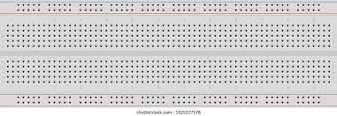
5) Buzzer:
A Piezo buzzer is an electric device used to produce a tone. These lightweight and simplyconstructed buzzers are inexpensive yet reliable and come in a range of sizes and frequencies to meet the needs of nearly any application.
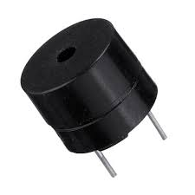

- Proposed System:
The proposed system is a smart, IoT-enabled food spoilage detection setup that monitors environmental parameters like gas emissions, temperature, and humidity to detect food spoilage. It uses sensors like MQ3 (gas sensor), IR sensor, and ultrasonic sensor integrated with an Arduino Uno microcontroller. The data is displayed locally on an LCD and transmitted online via the ESP8266 WiFi module for remote monitoring. Alert mechanisms like LED indicators and buzzer/servo mechanisms inform users of spoilage in real time.

Working Mechanism:
- Sensing: The MQ3 detects gases (ethanol, etc.) released by spoiling food. IR and ultrasonic sensors detect food presence or position.
- Processing: Data is sent to the Arduino Uno, which processes the sensor readings.
- Alert System: If values cross predefined spoilage thresholds, the Arduino triggers alerts (LED, buzzer, or servo mechanism).
- Display & Monitoring: Readings are shown on the LCD for local use and sent via ESP8266 for remote monitoring through cloud platforms or apps.
- Power Supply: A 2A adaptor and 7805 circuit regulate and supply consistent power.

Features of the Proposed System:
- Real-Time Food Spoilage Detection
  - Detects gases released from decaying food using MQ3.
- IoT Integration
  - ESP8266 enables cloud data logging and remote alerts.
- User Alerts
  - LED indicators and optional buzzer/servo system notify users immediately.
- Compact and Portable Design
  - Constructed with lightweight components and cardboard casing.
- LCD Display Interface
  - Easy-to-read local display of status and sensor values.
- Cost-Efficient
  - Built with affordable, easily available components.
- Scalable & Customizable
  - Can be scaled for large food storage units or commercial kitchens.

- BLOCK & CIRCUIT DIAGRAM

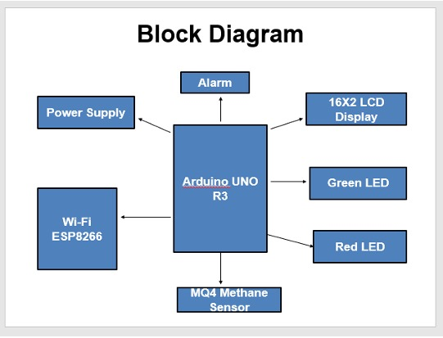
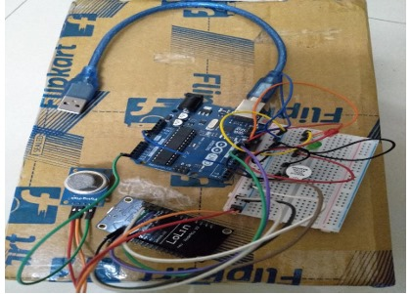
- INTERACTING ARDUINO WITH ARDUINO IDE

- Connect Arduino to PC via USB cable
- Open Arduino IDE,select the right board and port
- Copy the below code and open with Arduino IDE

#include <SoftwareSerial.h>
SoftwareSerial nodemcu(8, 9);

int pinRedLed = 12;
int pinGreenLed = 11;
int pinSensor = A5;
int THRESHOLD = 250;
int buzzer = 10;

int rdata = 0;
String mystring;
void setup()
{
Serial.begin(9600);
nodemcu.begin(9600);

pinMode(buzzer, OUTPUT);
pinMode(pinRedLed, OUTPUT);
pinMode(pinGreenLed, OUTPUT);
pinMode(pinSensor, INPUT);
}
void loop()
{
// put your main code here, to run repeatedly:
int rdata = analogRead(pinSensor);
Serial.print("Methane Range: ");
Serial.println(rdata);

if(rdata >= THRESHOLD){
digitalWrite(pinRedLed, HIGH);
digitalWrite(pinGreenLed, LOW);
digitalWrite(buzzer, HIGH);
delay(50);

}else
{
digitalWrite(pinRedLed, LOW);
digitalWrite(pinGreenLed, HIGH);
digitalWrite(buzzer, LOW);
}

if (nodemcu.available() > 0)
{
char data;
data = nodemcu.read();
Serial.println(data);
}
if(rdata < 250){
mystring = mystring + "Methane Range: " + rdata;
nodemcu.println(mystring);
Serial.println(mystring);

}else
{
mystring = "Food Spoiled";
nodemcu.println(mystring);
Serial.println(mystring);
}

mystring = "";
delay(1000);
}

- Project Layout:
How to connect Buzzer, LEDs, MQ4 Sensor and NodeMCU to Arduino UNO

1) Connect Buzzer to Arduino UNO:
i) Positive terminal (long end) should be connected to any digital pin, say digital pin D10 on Arduino.
ii) Negative terminal (short end) should be connected to common ground on breadboard.

2) Connect LEDs to Arduino UNO:
i) Positive terminal to digital pin D13 or any other digital pin on Arduino.
ii) Negative terminal to common ground on breadboard.

3) Connect NodeMCU to Arduino UNO:
i) Here we are using NodeMCU with ESP8266 12E WiFi Module. Serial communication is required to transfer data between Arduino and NodeMCU.
ii) Rx of NodeMCU to any digital pin, say D9.
iii) Tx of NodeMCU to any digital pin, say D8.
iv) GND to GND of Arduino (or common GND).
v) Vin pin of NodeMCU to 3.3V supply of Arduino.

4) How to connect MQ4 Sensor to Arduino UNO R3:
i) Analog pin of sensor i.e. A0 to A5 or any analog pin of Arduino.
ii) D0 digital pin is kept as it is.
iii) GND pin of sensor is connected to GND pin of Arduino (or common GND).
iv) Vcc pin of sensor to 5V power supply pin of Arduino.
For all these data captured by sensor to be transferred from Arduino to NodeMCU and also to the Blynk app cloud through ESP8266 12E WiFi module, few libraries are to be installed in Arduino IDE application.
It includes:
i) ESP8266 by community version
ii) SoftwareSerial library
iii) Blynk library

- Coding and Output:
NodeMcu Program

#define BLYNK_PRINT Serial
#include <ESP8266WiFi.h>
#include <BlynkSimpleEsp8266.h>
#include <SoftwareSerial.h>

String sdata;
char auth[] = "kvBuZuwcA_JGDj0DBMBlgXfqfe9-B_Lr";

// Your WIFI credentials.
// Set password to "" for open networks.
char ssid[] = "vivo 1814";
char pass[] = "priyateli2831";
BlynkTimer timer;

String myString; // complete message from Arduino, which consists of sensors data
char rdata; // received characters
// This function sends Arduino's up time every second to Virtual Pin (1).
// In the app, Widget's reading frequency should be set to PUSH. This means
// that you define how often to send data to Blynk App.
void myTimerEvent()
{
// You can send any value at any time.
// Please don't send more that 10 values per second.
Blynk.virtualWrite(V1, millis() / 1000);

}
void setup()
{
// Debug console
Serial.begin(9600);
Blynk.begin(auth, ssid, pass);
timer.setInterval(1000L, sensorvalue1);

}
void loop()
{
if (Serial.available() == 0)
{
Blynk.run();
timer.run(); // Initiates BlynkTimer
}

if (Serial.available() > 0)
{
rdata = Serial.read();
myString = myString + rdata;
}
}

void sensorvalue1()
{
sdata = myString ;
// You can send any value at any time.
// Please don't send more that 10 values per second.
Blynk.virtualWrite(V12, sdata);
myString = "";
}

Output:
- Quality is monitored constantly by sensors and readings are displayed on screen.
- When abnormal readings are detected in any readings i.e., MQ3 sensor, it displays the food spoiling message the LED screen
- It also displays a message of “Food Spoilage” on the Blynk application dashboard
- The data over Dashboard gets updated every seconds. • User will also be able to see the values on serial monitor of Arduino IDE.

- CONCLUSION:
Food poisoning has been the source of innumerable diseases, to reduce and avoid illness we use sensors to determine the freshness of household food items like fruits. The Arduino sensors can detect gas emissions Using sensors to detect the presence of these values among foods can help detect food spoilage early and prevent the consumption of spoiled food. These techniques can be further developed to include other types of gas sensors and foods to increase the sensitivity of such detection methods. This system consists of a hardware device i.e Mq4 Methane Sensor which checks the quality and freshness of food.

The IoT-Based Food Spoilage Detection System is a smart, low-cost solution designed to improve food safety and reduce waste by detecting early signs of spoilage. By integrating sensors like the MQ3 or MQ4 gas sensor with the Arduino Uno and ESP8266 WiFi module, the system effectively monitors environmental conditions such as gas emissions, which are indicators of decaying food. Additional components like LEDs, buzzers, LCDs, and servo motors enhance the system’s responsiveness by providing visual, audible, and physical alerts when spoilage is detected.
This project showcases the practical application of IoT in day-to-day life, especially in homes, grocery stores, and the food supply chain. The integration with the Blynk app allows users to monitor food conditions remotely in real time, making the system both accessible and user-friendly. The use of simple components and open-source platforms ensures that the system remains affordable and customizable.
In conclusion, this project not only promotes health and hygiene but also encourages technology-driven sustainable practices by helping users take timely action to prevent food decay. With minor enhancements, it can be further developed into a commercial-grade solution for industrial food monitoring and smart kitchens.

